|  |  |
| --- | --- |
| **Title** | 3rd homework in the Electric Circuit Theory class by 201923250 |

|  |  |  |  |
| --- | --- | --- | --- |
| **Author** | 201923250 | **Date** | 9.15.2020 |

**Summarization of chapters**

A second-order circuit is defined by a second-order differential equation. It consists of resistors and the equivalent of two energy storage elements. Knowledge of the series RLC circuit's natural reaction is a required basis for future studies in filter architecture and communications networks. This is a differential equation of second order and is the explanation for naming the RLC circuits in second-order circuits in this part. Many practical applications are found in parallel RLC circuits, especially in communication networks and filter design.

An understanding of the natural response of the series RLC circuit is a necessary background for future studies in filter design and communications networks. parallel RLC circuits find many practical applications, notably in communications networks and filter designs.

**Example problems with explanation**

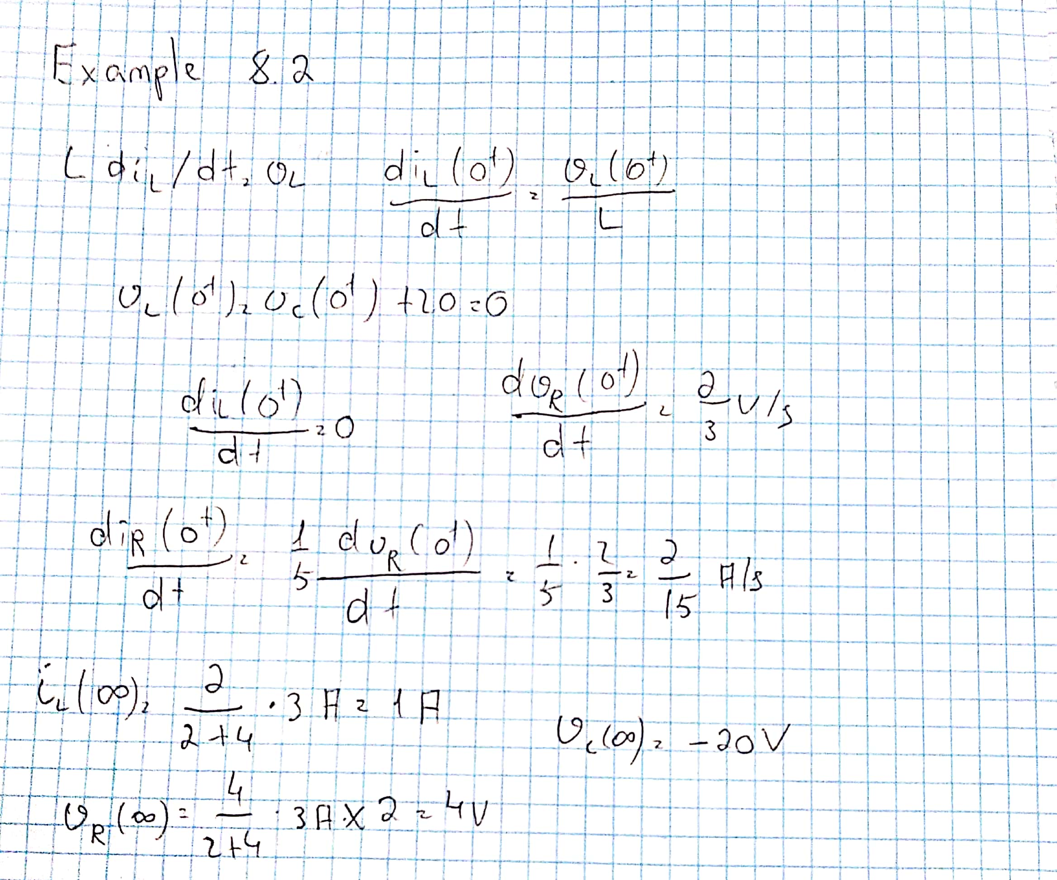

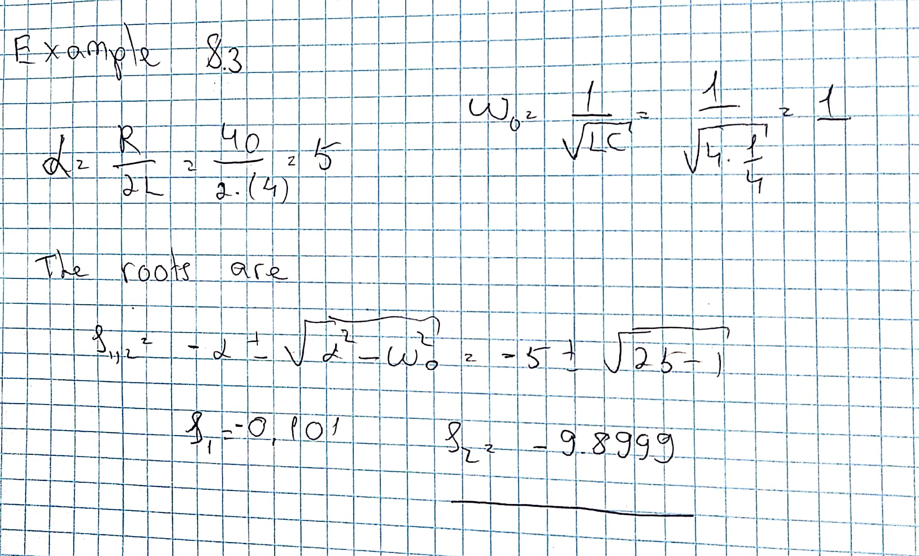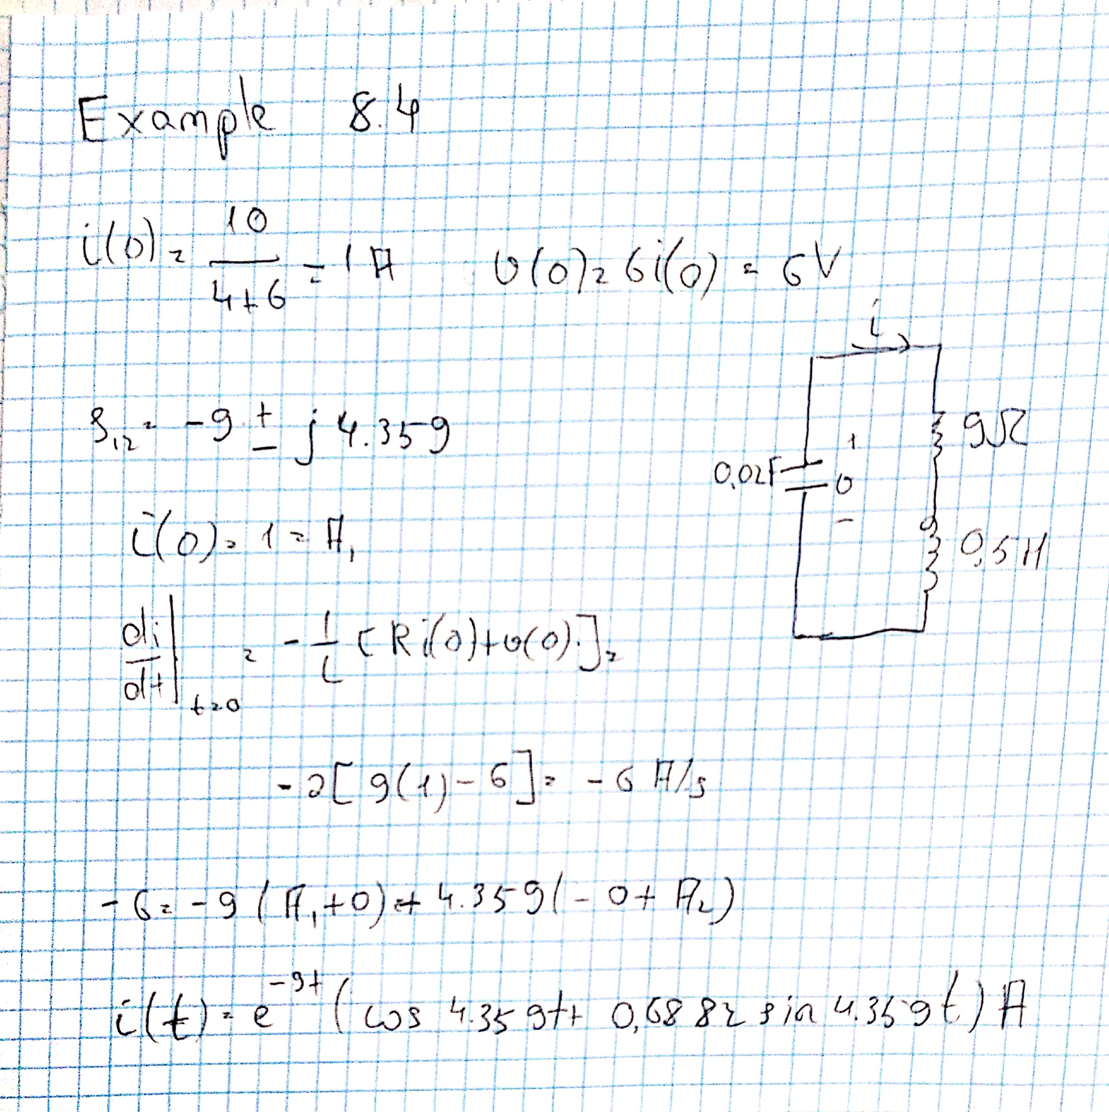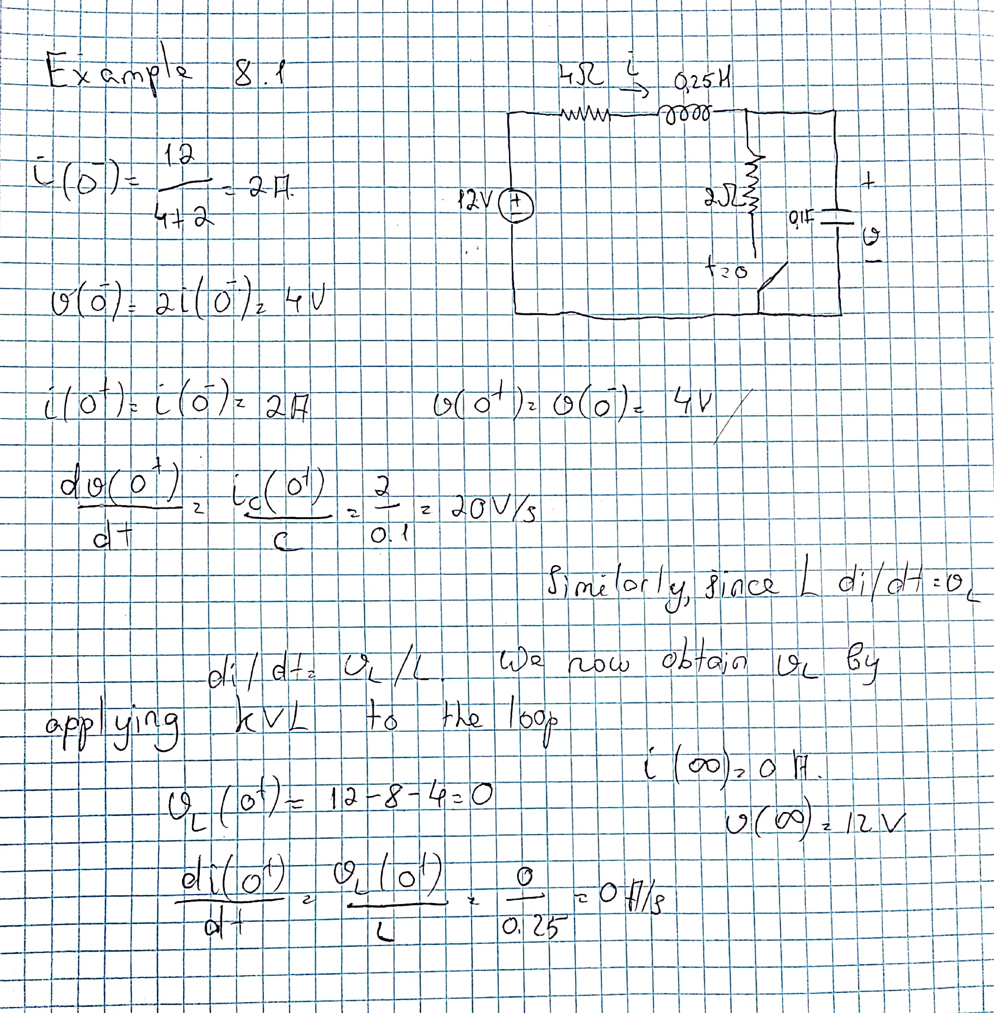

**Student ID : 201923250**

**Name : KobilovIlkhomjon**